Builders and Contractors.
Bond, Robert William, Builder, Contractor, and Timber Merchant,
Liardet Street, New Plymouth. And Private residence, Fitzroy.
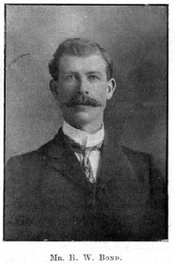
Mr. R. W. Bond.
business was established by Mr. Bond in the year 1897.
The office, store, workshop, and timber yards stand on a section of three-eighths of an acre in Liardet Street.
Mr. Bond has put up many buildings in Taranaki, including the Patea Freezing Works, the New Zealand Express Company's building (the first brick structure in New Plymouth), the Imperial Hotel, with a large party brick wall,
Messrs J. B. MacEwan and Company's building; and the Technical School, a large building in brick.
A special feature of the business is the construction of brick work, including freezing and cooling chambers, drains, culverts and concrete work.
About ten persons are employed, on the average. Mr. Bond was born in 1873 in Hull, England.
He came to New Zealand at an early age, with his parents, Christopher & Sarah Bond in 1875 and settled at Sentry Hill in 1876.
He was educated at Lepperton, and learned his trade at Waitara, and New Plymouth, and worked as a journeyman until starting business on his own account.
He was a Master Mason of Lodge Sir Donald McLean, English Constitition, Waireka. Mr. Bond married a daughter of Mr. James MacKinder, of Inglewood, in the year 1897.

